 **KL UNIVERSITY**

**CULTURAL FEST MANAGEMENT SYSTEM**

**By K.CHANDRA TEJA**

TABLEOF CONTENTS

**1.ABSTARCT**…………………………………………………………Page No:06

**2.INTRODUCTION**…………………………………………………. Page No:07

3.PROJECT DESCRIPTION…………………………………………… Page No:08

4.SRS DOCUMENT…………………………………………………. Page No:09

5.PROCESS ARCHITECTURE DESIGN…………………………… Page No:11

6.USECASE DIAGRAM…………………………………………...… Page No:15

7.CLASS DIAGRAM………………………………………………… Page No:16

8.SNAP SHOTS…………………………………………….………… Page No:17

**9.SOURCE CODE……………………………………………………...……** Page No:18

**10.CONCLUSION……………………………………………….…………**Page No:28

11.REFERENCES………………………………………………………Page No:29

ABSTRACT

The Cultural Fest Management System Project is a software solution designed to manage various activities and events associated with cultural festivals. The system aims to streamline the process of managing cultural events, including registration, scheduling, and communication. It provides a centralized platform.

that enables event organizers to manage multiple events and keep track of all festival-related activities. The project is developed in Apache Netbeans IDE by using Graphical user interface components(Java Swing Components) and database is developed in Mysql workbench to provide a user-friendly and efficient solution. This report discusses the various features of the Cultural Fest

The Cultural Fest Management System Project is a comprehensive software

solution that simplifies the management of cultural festivals. It offers a unified platform that facilitates event planning, execution, and evaluation. The system leverages advanced technologies to deliver a seamless and user-friendly

experience for festival organizers and attendees alike. The project's architecture

and design are robust, scalable, and customizable to meet the diverse needs of cultural events. The Cultural Fest Management System Project provides several benefits, such as increased efficiency, better communication, and improved data management, leading to better festival outcomes and experiences.

INTRODUCTION

The Cultural Fest Management System Project is an application designed to manage and streamline the various tasks involved in organizing a cultural festival. It is a comprehensive software system that helps event organizers to efficiently manage all aspects of cultural events, such as planning, organizing.

This project includes 2 types of users 1.Admin and 2.Students or faculty

Admins can add, update, or delete details of the festival, invite guests, add prizes, create schedules, and announce the winners. Users can register for the event, log in, update their profiles, view details of the festival, including prizes, judges or guests, and check the festival schedule. Additionally, users can see the list of winners of the festival.

PROJECT DESCRIPTION

This project is about creating the database about CULTURAL FEST MANAGEMENT

The cultural fest management project in college is a system that aims to automate and streamline the process of organizing a cultural fest or event in a college. This project involves developing a application that helps the organizers of the cultural fest to manage various tasks involved in the event management process.

The system will have different modules that cater to different functionalities of the event management process. The modules may include event registration, participant.

management, budget management, event scheduling.

The event registration module will allow participants to register themselves for the event, including details like their name, contact information, and their chosen cultural activity or performance. The participant management module will enable the organizers to track the participants, their contact details, and other relevant information.

The budget management module will help the organizers to keep track of the expenses and income related to the event.

The event scheduling module will enable the organizers to schedule the event and allocate time slots for each performance. This module will also help the organizers to avoid clashes and overlaps in the schedule.

Overall, the cultural fest management project in college will help the organizers to

manage the event more efficiently, reduce manual work, and avoid errors.

SOFTWARE REQUIREMENT SPECIFICATION(SRS)DOCUMENT

Software Requirements Specification (SRS) for Cultural Fest Management System

Introduction

The Cultural Fest Management System is a application that is designed to

manage and organize cultural festivals. This software is designed to be used by event organizers and festival managers who want to streamline their festival management process. The system provides features like user registration, participant management, cash prize management, guest management, winners management, and winners details display.

Scope

The Cultural Fest Management System aims to provide a user-friendly interface to manage and organize cultural festivals. The system provides features to manage the entire festival management process, including user registration, participant management, cash prize management, guest management, details display.

Functional Requirements

The following are the functional requirements for the Cultural Fest Management System:

3.1 User Management

The system shall allow users to register to participate in the festival. Users will be required

to provide their name, email address, and contact details during registration.

3.2 Cash Prize Management

The system shall provide features to manage cash prizes for the winners. The system shall provide options to enter the cash prize amount for each category of the event.

3.3 Guest Management

The system shall provide features to manage guests attending the festival. The system shall allow event organizers to add, modify and delete guest details.

3.4 EVENT SHEDULE MANAGEMENT

The system shall provide features to display the details of the schedule timings. The system shall allow event organizers to display the details of the schedule for each category of the festival.

3.5 FACULTY MANAGEMENT

The system shall provide features to display the details of the coordinating faculty. The system shall allow event organizers to display the details of the coordinating faculty for

each category of the festival.

3.6 VOLUNTEER MANAGEMENT

The system shall provide features to display the details of the volunteers. The system shall allow event organizers to display the details of the volunteers for each category of the

festival.

3.7 BUDGET MANAGEMENT

The system shall provide features to display the details of the Fest Budget. The system shall allow event organizers to display the details of the Fest Budget for each category of the festival.

NON-FUNCTIONAL REQUIREMENTS

4.1 Performance

The system shall be designed to handle many users simultaneously. The system shall

respond to user requests within a reasonable time.

4.2 Usability

The system shall be designed to be user-friendly and easy to use. The system shall provide clear instructions for each feature and shall have a simple user interface.

4.3 Security

The system shall be designed to be secure and protect user information. The system shall ensure that user information is encrypted during transmission and storage.

PROCESS ARCHITECTURE DIAGRAM

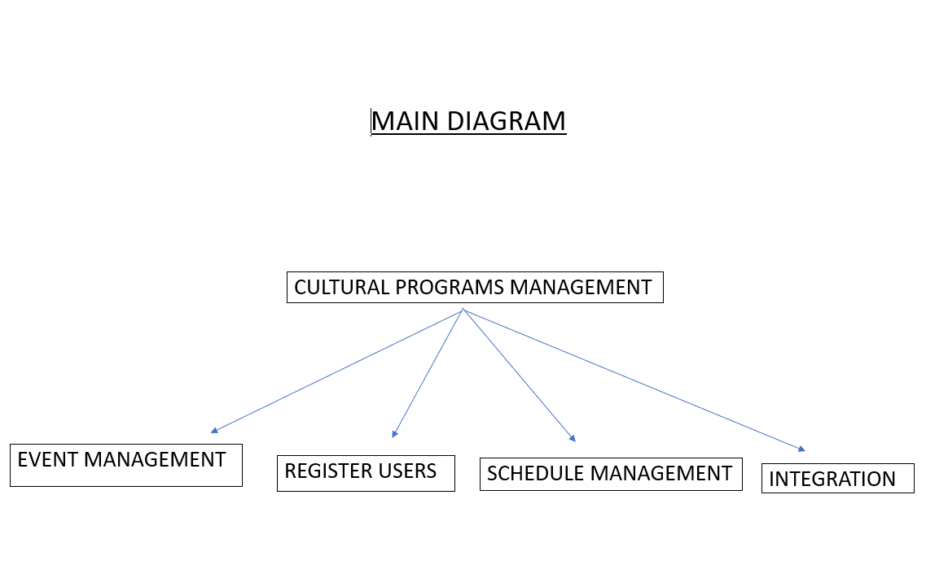

SUB SYSTEM-1

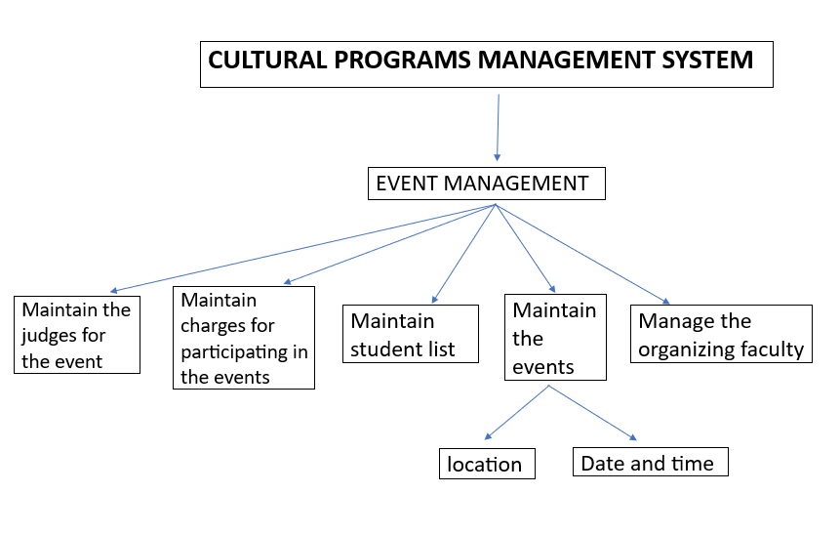

SUB SYSTEM-2

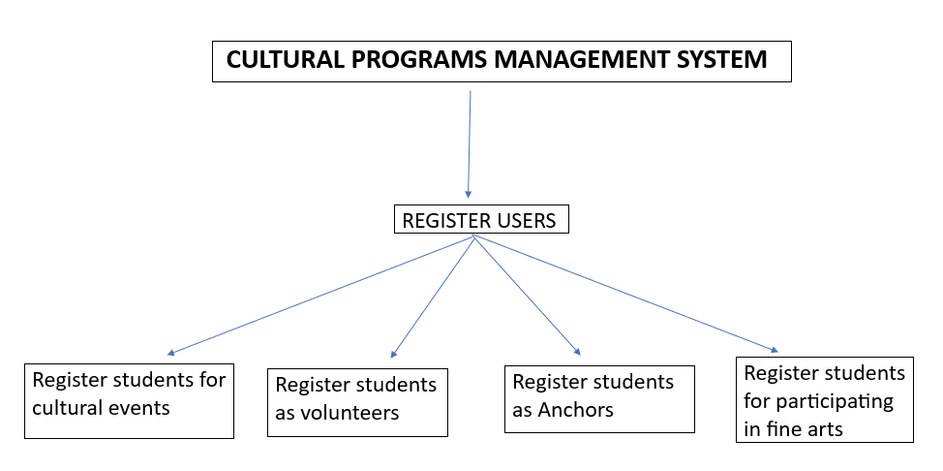

SUB SYSTEM-3

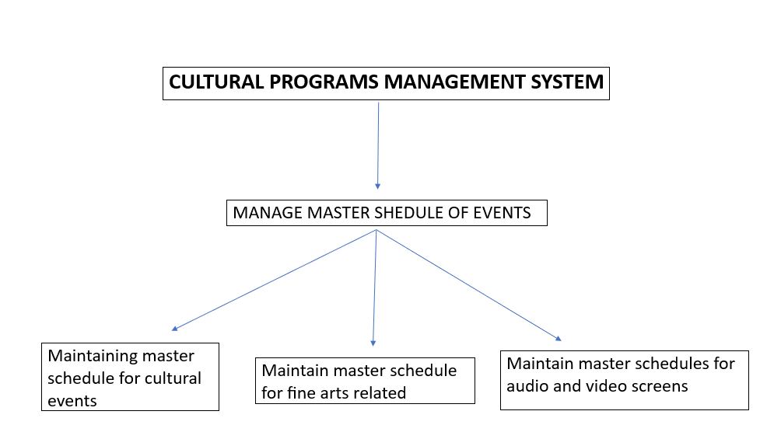

USECASE DIAGRAM

________________________________________________________

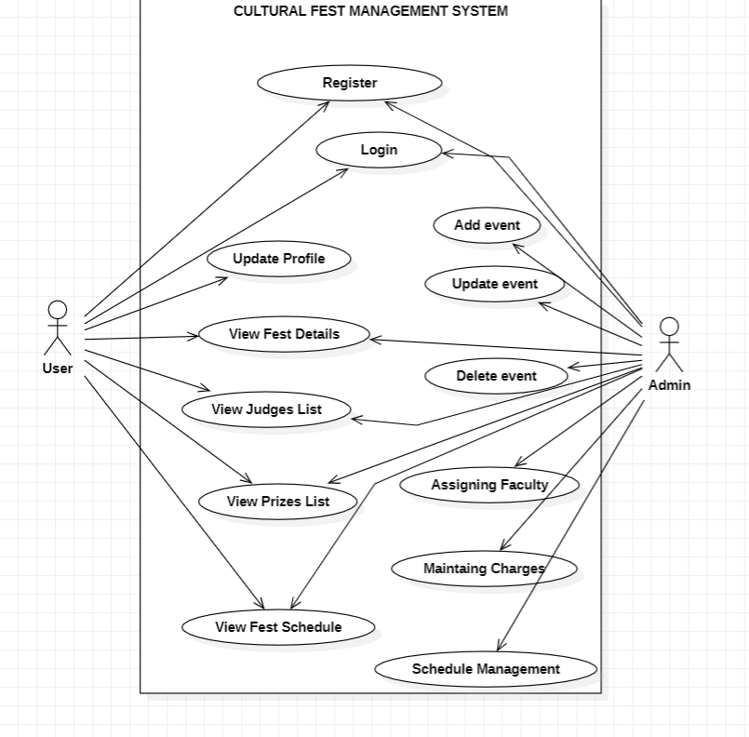

CLASS DIAGRAM

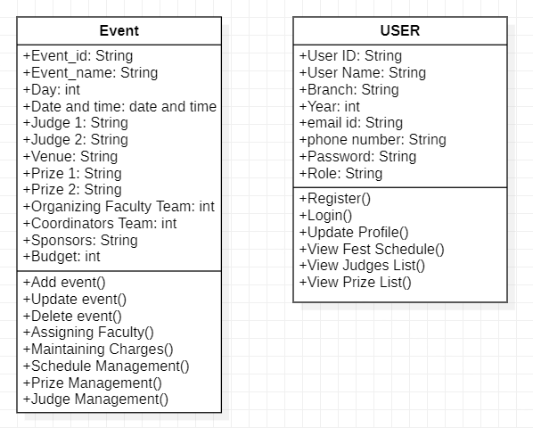

SNAPSHOTS WITH SOURCE CODE

HOME PAGE

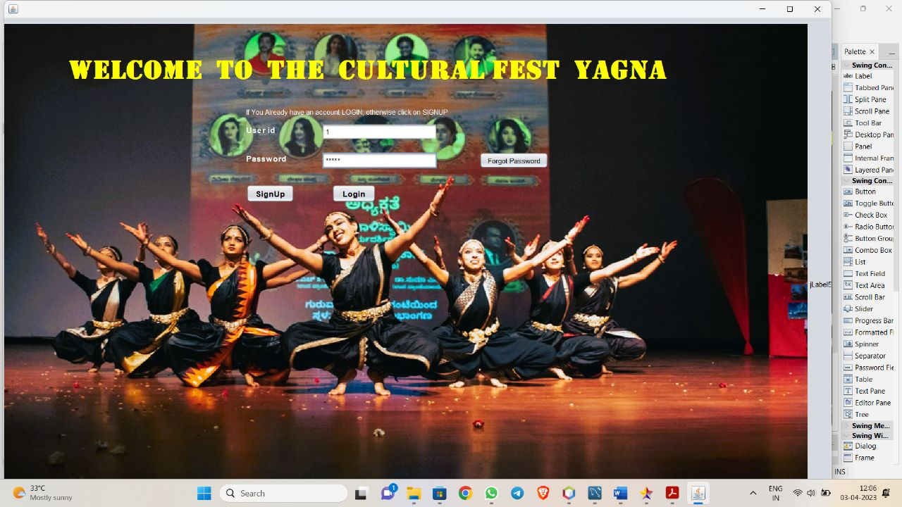

NOW THE ADMIN IS ENTERING HIS CREDENTIALS SO THE ADMIN PAGE STARTS

SOURCE CODE FOR HOME PAGE

if((tx1.getText().contains("1")) && (tx2.getText().contains("admin")))

{

Adminpage a=new Adminpage();

a.show();

dispose();

}

else{

try{

Class.forName("com.mysql.jdbc.Driver");

Connection con =DriverManager.getConnection("jdbc:mysql://localhost:3306/demo","root","root");

String query="select * from user_details where id=?";

java.sql.PreparedStatement ps=con.prepareStatement(query);

ps.setString(1,tx1.getText());

ResultSet rs=ps.executeQuery();

if(rs.next())

{

String query1="select * from user_details where id= ? and password=?";

java.sql.PreparedStatement ps1=con.prepareStatement(query1);

ps1.setString(1,tx1.getText());

ps1.setString(2,tx2.getText());

ResultSet rs1=ps1.executeQuery();

if(rs1.next())

{

userhome w=new userhome(tx1.getText());

w.show();

dispose();

}

else{

JOptionPane.showMessageDialog(null,"password incorrect");

}

}

else{

JOptionPane.showMessageDialog(null,"user not there");

tx1.setText("");

tx2.setText("");

}

ps.close();

con.close();

}

catch(Exception e){

JOptionPane.showMessageDialog(null,e);

}

ADMIN PAGE

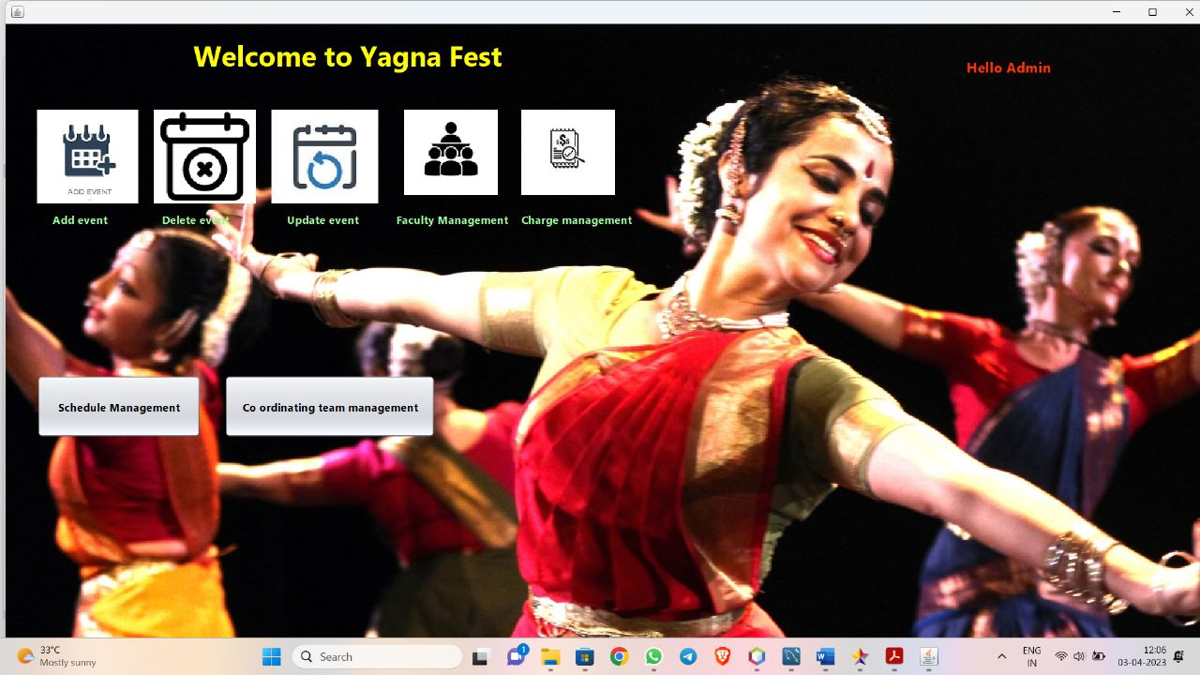

Source code for the admin page

private void jLabel3MouseClicked(java.awt.event.MouseEvent evt) {

// TODO add your handling code here:

admin_modifications a=new admin_modifications();

a.show();

dispose();

}

private void jLabel3MousePressed(java.awt.event.MouseEvent evt) {

// TODO add your handling code here:

}

private void jLabel5MouseClicked(java.awt.event.MouseEvent evt) {

// TODO add your handling code here:

deleteevent d=new deleteevent();

d.show();

dispose();

}

private void jLabel6MouseClicked(java.awt.event.MouseEvent evt) {

// TODO add your handling code here:

updateevent u=new updateevent();

u.show();

dispose();

}

private void jLabel7MouseClicked(java.awt.event.MouseEvent evt) {

// TODO add your handling code here:

Faculty_management a=new Faculty_management();

a.show();

dispose();

}

private void jLabel10MouseClicked(java.awt.event.MouseEvent evt) {

// TODO add your handling code here:

charge_management c=new charge_management();

c.show();

dispose();

}

private void jButton2ActionPerformed(java.awt.event.ActionEvent evt) {

// TODO add your handling code here:

Schedule_management m=new Schedule_management();

m.show();

dispose();

}

ADD EVENT PAGE

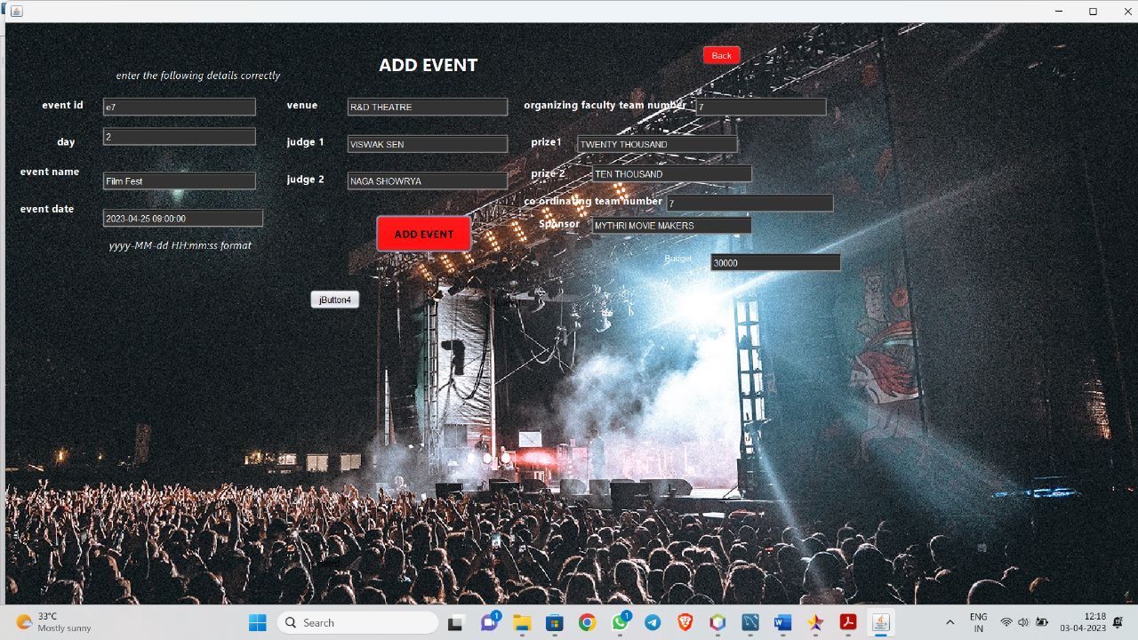

SOURCE CODE FOR ADD EVENT PAGE

try {

Class.forName("com.mysql.jdbc.Driver");

Connection con = DriverManager.getConnection("jdbc:mysql://localhost:3306/demo", "root", "root");

String query = "INSERT INTO event_details VALUES (?, ?, ?, ?, ?, ?, ?, ?, ?, ?, ?, ?, ?)";

PreparedStatement ps = con.prepareStatement(query);

ps.setString(1, txeid.getText());

ps.setInt(2, Integer.parseInt(txday1.getText()));

ps.setString(3, txevname.getText());

String dateTimeString = txevdate.getText();

SimpleDateFormat sdf = new SimpleDateFormat("yyyy-MM-dd HH:mm:ss");

java.util.Date dateTime = sdf.parse(dateTimeString);

java.sql.Timestamp sqlTimestamp = new java.sql.Timestamp(dateTime.getTime());

ps.setTimestamp(4, sqlTimestamp);

ps.setString(5, txvenue.getText());

ps.setString(6, txjudge1.getText());

ps.setString(7, txjudge2.getText());

ps.setInt(8, Integer.parseInt(txfacnumber.getText()));

ps.setString(9, txprize1.getText());

ps.setString(10, txprize2.getText());

ps.setInt(11, Integer.parseInt(txcoordteamno1.getText()));

ps.setString(12, txsponsor.getText());

ps.setInt(13, Integer.parseInt(jTextField2.getText()));

ps.executeUpdate();

ps.close();

con.close();

JOptionPane.showMessageDialog(this,"Event Inserted SUCCESFULLY");

} catch (Exception e) {

JOptionPane.showMessageDialog(this, e);

}

DELETE EVENT PAGE

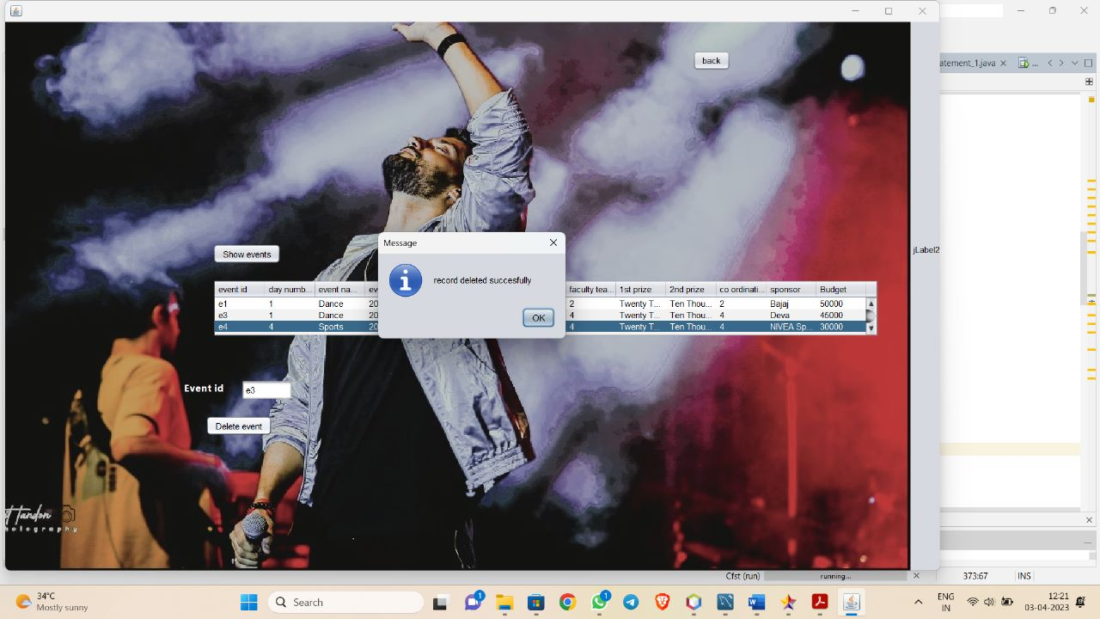

SOURCE CODE FOR DELETE EVENT

try{

Class.forName("com.mysql.jdbc.Driver");

Connection con =DriverManager.getConnection("jdbc:mysql://localhost:3306/demo","root","root");

String query="insert into faculty_info values(?,?,?,?)";

DefaultTableModel model = (DefaultTableModel) jTable3.getModel();

java.sql.PreparedStatement ps=con.prepareStatement(query);

for (int i = 0; i < model.getRowCount(); i++) {

String forgid = model.getValueAt(i, 0).toString();

String fid = model.getValueAt(i, 1).toString();

String ename = model.getValueAt(i, 2).toString();

String mno= model.getValueAt(i, 3).toString();

if (forgid != null && fid != null && ename != null && mno != null) {

ps.setString(1, forgid);

ps.setString(2, fid);

ps.setString(3, ename);

ps.setString(4, mno);

ps.addBatch();

ps.clearParameters();

if (i % 100 == 0) {

ps.executeBatch(); // Execute batch every 100 rows

}

}

}

ps.executeBatch(); // Execute remaining batch

JOptionPane.showMessageDialog(this, "successfully inserted");

DefaultTableModel model1=(DefaultTableModel)jTable1.getModel();

int r = jTable1.getRowCount();

model1.addRow(new String[]{model.getValueAt(0, 0).toString(),model.getValueAt(0, 1).toString(),model.getValueAt(0, 2).toString(),model.getValueAt(0, 3).toString()});

model.setRowCount(0);

model.addRow(new String[]{"","","",""});

ps.close();

con.close();

} catch (SQLException ex) {

Logger.getLogger(Faculty_management.class.getName()).log(Level.SEVERE, null, ex);

} catch (ClassNotFoundException ex) {

Logger.getLogger(Faculty_management.class.getName()).log(Level.SEVERE, null, ex);

}

}

private void jButton3ActionPerformed(java.awt.event.ActionEvent evt) {

// TODO add your handling code here:

try {

// Load the MySQL driver

Class.forName("com.mysql.jdbc.Driver");

// Create a connection to the MySQL database

Connection connection = DriverManager.getConnection("jdbc:mysql://localhost:3306/demo", "root", "root");

// Create a statement to execute the SQL query

Statement statement = connection.createStatement();

// Execute the SQL DELETE statement to remove all data from the table

String sql = "DELETE FROM faculty_info;";

int rowsAffected = statement.executeUpdate(sql);

JOptionPane.showMessageDialog(this,rowsAffected+"faculty deleted");

// Output the number of rows affected

// Close the statement and connection

statement.close();

connection.close();

} catch (ClassNotFoundException e) {

System.err.println("Unable to load database driver: " + e.getMessage());

} catch (SQLException e) {

System.err.println("Unable to connect to database: " + e.getMessage());

}

Update Event Page

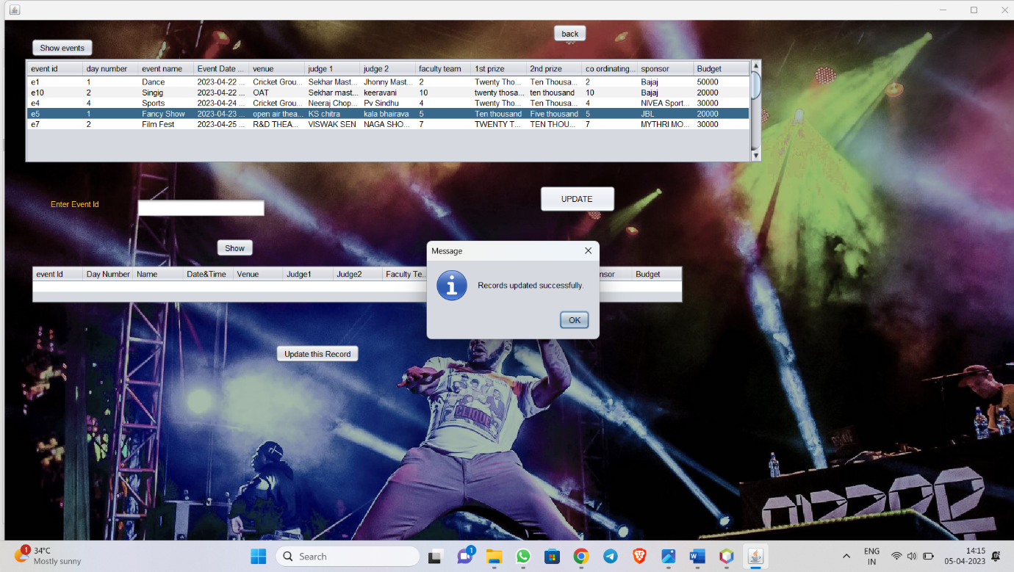

Code:

private void jButton1ActionPerformed(java.awt.event.ActionEvent evt) {

// TODO add your handling code here:

try {

Class.forName("com.mysql.jdbc.Driver");

Connection con = DriverManager.getConnection("jdbc:mysql://localhost:3306/demo", "root", "root");

Statement st = con.createStatement();

String sql = "SELECT * FROM event_details";

ResultSet rs = st.executeQuery(sql);

DefaultTableModel model = (DefaultTableModel) jTable1.getModel();

model.setRowCount(0);

while (rs.next()) {

String dateTimeString = rs.getTimestamp(4).toString();

SimpleDateFormat sdf = new SimpleDateFormat("yyyy-MM-dd HH:mm:ss");

java.util.Date dateTime = sdf.parse(dateTimeString);

String formattedDateTimeString = sdf.format(dateTime);

model.addRow(new String[]{rs.getString(1), String.valueOf(rs.getInt(2)), rs.getString(3), formattedDateTimeString, rs.getString(5), rs.getString(6), rs.getString(7), String.valueOf(rs.getInt(8)), rs.getString(9), rs.getString(10), String.valueOf(rs.getInt(11)), rs.getString(12), String.valueOf(rs.getInt(13))});

}

rs.close();

st.close();

con.close();

} catch (Exception e) {

JOptionPane.showMessageDialog(this, e);

}

}

private void jButton2MouseEntered(java.awt.event.MouseEvent evt) {

// TODO add your handling code here:

}

private void jButton2ActionPerformed(java.awt.event.ActionEvent evt) {

// TODO add your handling code here:

try {

Class.forName("com.mysql.jdbc.Driver");

Connection con = DriverManager.getConnection("jdbc:mysql://localhost:3306/demo", "root", "root");

DefaultTableModel model = (DefaultTableModel) jTable1.getModel();

String updateQuery = "UPDATE event_details SET day=?, ename=?, edate_time=?, venue=?, judge1=?, judge2=?, org_faculty_team_number=?, prize1=?, prize2=?,cordinating_tno=?, sponsor=?,budget=? WHERE e_id=?";

java.sql.PreparedStatement st = con.prepareStatement(updateQuery);

for (int i = 0; i < model.getRowCount(); i++) {

String id = model.getValueAt(i, 0).toString();

int d = Integer.parseInt(model.getValueAt(i, 1).toString());

String ename = model.getValueAt(i, 2).toString();

String dateTimeString = model.getValueAt(i, 3).toString(); // date and time in string format

SimpleDateFormat sdf = new SimpleDateFormat("yyyy-MM-dd HH:mm:ss"); // format for date and time

java.util.Date dateTime = sdf.parse(dateTimeString);

java.sql.Timestamp sqlTimestamp = new java.sql.Timestamp(dateTime.getTime()); // convert to sql timestamp

String venue = model.getValueAt(i, 4).toString();

String j1 = model.getValueAt(i, 5).toString();

String j2 = model.getValueAt(i, 6).toString();

int oft = Integer.parseInt(model.getValueAt(i, 7).toString());

String p1 = model.getValueAt(i, 8).toString();

String p2 = model.getValueAt(i, 9).toString();

int ctn = Integer.parseInt(model.getValueAt(i, 10).toString());

String sponsors = model.getValueAt(i, 11).toString();

int budgeT=Integer.parseInt(model.getValueAt(i, 12).toString());

st.setInt(1, d);

st.setString(2, ename);

st.setTimestamp(3, sqlTimestamp); // set timestamp instead of date

st.setString(4, venue);

st.setString(5, j1);

st.setString(6, j2);

st.setInt(7, oft);

st.setString(8, p1);

st.setString(9, p2);

st.setInt(10, ctn);

st.setString(11, sponsors);

st.setInt(12, budgeT);

st.setString(13, id);

st.addBatch();

}

st.executeBatch();

JOptionPane.showMessageDialog(this, "Records updated successfully.");

} catch (Exception e) {

JOptionPane.showMessageDialog(this, e.getMessage());

}

}

private void jButton3ActionPerformed(java.awt.event.ActionEvent evt) {

// TODO add your handling code here:

Adminpage a=new Adminpage();

a.show();

dispose();

}

private void jButton4ActionPerformed(java.awt.event.ActionEvent evt) {

try {

Class.forName("com.mysql.jdbc.Driver");

Connection con = DriverManager.getConnection("jdbc:mysql://localhost:3306/demo", "root", "root");

String sq = "SELECT * FROM event_details WHERE e_id=?";

java.sql.PreparedStatement ps = con.prepareStatement(sq);

ps.setString(1, jTextField1.getText());

ResultSet rs = ps.executeQuery();

if (!rs.next()) {

JOptionPane.showMessageDialog(this, "Record not found.");

} else {

String query1 = "SELECT * FROM event_details WHERE e_id=?";

java.sql.PreparedStatement ps1 = con.prepareStatement(query1);

ps1.setString(1, jTextField1.getText());

rs = ps1.executeQuery();

DefaultTableModel model = (DefaultTableModel) jTable2.getModel();

model.setRowCount(0);

while (rs.next()) {

String dateTimeString = rs.getTimestamp(4).toString();

SimpleDateFormat sdf = new SimpleDateFormat("yyyy-MM-dd HH:mm:ss");

java.util.Date dateTime = sdf.parse(dateTimeString);

String formattedDateTimeString = sdf.format(dateTime);

model.addRow(new String[]{rs.getString(1), String.valueOf(rs.getInt(2)), rs.getString(3), formattedDateTimeString, rs.getString(5), rs.getString(6), rs.getString(7), String.valueOf(rs.getInt(8)), rs.getString(9), rs.getString(10), String.valueOf(rs.getInt(11)), rs.getString(12), String.valueOf(rs.getInt(13))});

}

}

con.close();

} catch (Exception e) {

JOptionPane.showMessageDialog(this, e.getMessage());

}

// TODO add your handling code here:

}

private void jButton5ActionPerformed(java.awt.event.ActionEvent evt) {

// TODO add your handling code here:

try {

Class.forName("com.mysql.jdbc.Driver");

Connection con = DriverManager.getConnection("jdbc:mysql://localhost:3306/demo", "root", "root");

DefaultTableModel model2 = (DefaultTableModel) jTable2.getModel();

String updateQuery = "UPDATE event_details SET day=?, ename=?, edate_time=?, venue=?, judge1=?, judge2=?, org_faculty_team_number=?, prize1=?, prize2=?,cordinating_tno=?, sponsor=?,budget=? WHERE e_id=?";

java.sql.PreparedStatement st = con.prepareStatement(updateQuery);

for (int i = 0; i < model2.getRowCount(); i++) {

String id = model2.getValueAt(i, 0).toString();

int d = Integer.parseInt(model2.getValueAt(i, 1).toString());

String ename = model2.getValueAt(i, 2).toString();

String dateTimeString = model2.getValueAt(i, 3).toString(); // date and time in string format

SimpleDateFormat sdf = new SimpleDateFormat("yyyy-MM-dd HH:mm:ss"); // format for date and time

java.util.Date dateTime = sdf.parse(dateTimeString);

java.sql.Timestamp sqlTimestamp = new java.sql.Timestamp(dateTime.getTime()); // convert to sql timestamp

String venue = model2.getValueAt(i, 4).toString();

String j1 = model2.getValueAt(i, 5).toString();

String j2 = model2.getValueAt(i, 6).toString();

int oft = Integer.parseInt(model2.getValueAt(i, 7).toString());

String p1 = model2.getValueAt(i, 8).toString();

String p2 = model2.getValueAt(i, 9).toString();

int ctn = Integer.parseInt(model2.getValueAt(i, 10).toString());

String sponsors = model2.getValueAt(i, 11).toString();

int budgeT=Integer.parseInt(model2.getValueAt(i, 12).toString());

st.setInt(1, d);

st.setString(2, ename);

st.setTimestamp(3, sqlTimestamp); // set timestamp instead of date

st.setString(4, venue);

st.setString(5, j1);

st.setString(6, j2);

st.setInt(7, oft);

st.setString(8, p1);

st.setString(9, p2);

st.setInt(10, ctn);

st.setString(11, sponsors);

st.setInt(12, budgeT);

st.setString(13, id);

st.addBatch();

}

st.executeBatch();

JOptionPane.showMessageDialog(this, "Records updated successfully.");

Statement st1=con.createStatement();

String sql="select * from event_details";

ResultSet rs=st1.executeQuery(sql);

DefaultTableModel model1=(DefaultTableModel)jTable1.getModel();

model1.setRowCount(0);

while (rs.next()) {

String dateTimeString = rs.getTimestamp(4).toString();

SimpleDateFormat sdf = new SimpleDateFormat("yyyy-MM-dd HH:mm:ss");

java.util.Date dateTime = sdf.parse(dateTimeString);

String formattedDateTimeString = sdf.format(dateTime);

model1.addRow(new String[]{rs.getString(1), String.valueOf(rs.getInt(2)), rs.getString(3), formattedDateTimeString, rs.getString(5), rs.getString(6), rs.getString(7), String.valueOf(rs.getInt(8)), rs.getString(9), rs.getString(10), String.valueOf(rs.getInt(11)), rs.getString(12), String.valueOf(rs.getInt(13))});

}

} catch (Exception e) {

JOptionPane.showMessageDialog(this, e.getMessage());

}

Faculty management Page

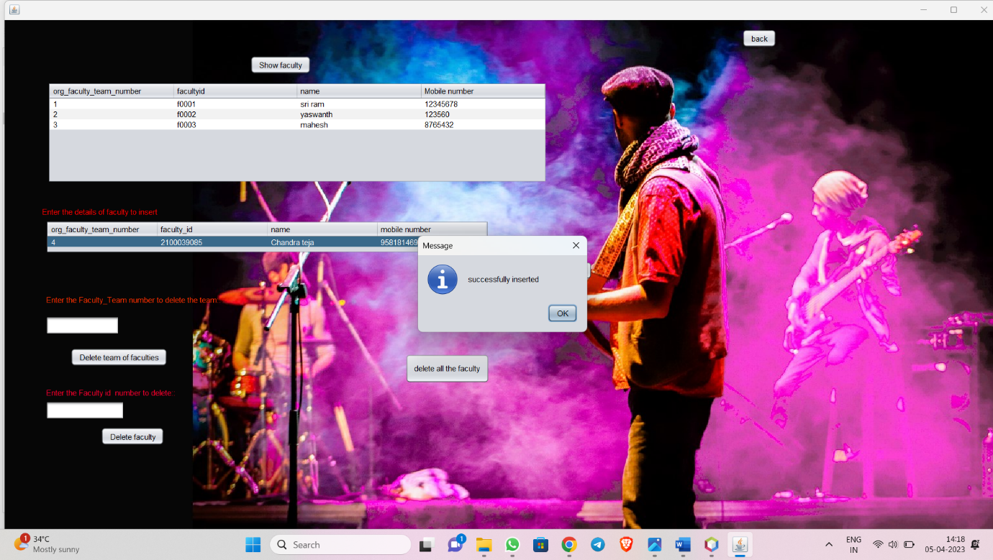

try{

Class.forName("com.mysql.jdbc.Driver");

Connection con =DriverManager.getConnection("jdbc:mysql://localhost:3306/demo","root","root");

Statement st=con.createStatement();

String sql="select * from faculty_info";

ResultSet rs=st.executeQuery(sql);

DefaultTableModel model=(DefaultTableModel)jTable1.getModel();

model.setRowCount(0);

while(rs.next())

{

model.addRow(new String[]{rs.getString(1),rs.getString(2),rs.getString(3),rs.getString(4)});

}

}

catch(Exception e)

{

JOptionPane.showMessageDialog(this,e);

}

}

private void jButton2ActionPerformed(java.awt.event.ActionEvent evt) {

// TODO add your handling code here:

try{

Class.forName("com.mysql.jdbc.Driver");

Connection con =DriverManager.getConnection("jdbc:mysql://localhost:3306/demo","root","root");

String query="insert into faculty_info values(?,?,?,?)";

DefaultTableModel model = (DefaultTableModel) jTable3.getModel();

java.sql.PreparedStatement ps=con.prepareStatement(query);

for (int i = 0; i < model.getRowCount(); i++) {

String forgid = model.getValueAt(i, 0).toString();

String fid = model.getValueAt(i, 1).toString();

String ename = model.getValueAt(i, 2).toString();

String mno= model.getValueAt(i, 3).toString();

if (forgid != null && fid != null && ename != null && mno != null) {

ps.setString(1, forgid);

ps.setString(2, fid);

ps.setString(3, ename);

ps.setString(4, mno);

ps.addBatch();

ps.clearParameters();

if (i % 100 == 0) {

ps.executeBatch(); // Execute batch every 100 rows

}

}

}

ps.executeBatch(); // Execute remaining batch

JOptionPane.showMessageDialog(this, "successfully inserted");

DefaultTableModel model1=(DefaultTableModel)jTable1.getModel();

int r = jTable1.getRowCount();

model1.addRow(new String[]{model.getValueAt(0, 0).toString(),model.getValueAt(0, 1).toString(),model.getValueAt(0, 2).toString(),model.getValueAt(0, 3).toString()});

model.setRowCount(0);

model.addRow(new String[]{"","","",""});

ps.close();

con.close();

} catch (SQLException ex) {

Logger.getLogger(Faculty_management.class.getName()).log(Level.SEVERE, null, ex);

} catch (ClassNotFoundException ex) {

Logger.getLogger(Faculty_management.class.getName()).log(Level.SEVERE, null, ex);

}

}

private void jButton3ActionPerformed(java.awt.event.ActionEvent evt) {

// TODO add your handling code here:

try {

// Load the MySQL driver

Class.forName("com.mysql.jdbc.Driver");

// Create a connection to the MySQL database

Connection connection = DriverManager.getConnection("jdbc:mysql://localhost:3306/demo", "root", "root");

// Create a statement to execute the SQL query

Statement statement = connection.createStatement();

// Execute the SQL DELETE statement to remove all data from the table

String sql = "DELETE FROM faculty_info;";

int rowsAffected = statement.executeUpdate(sql);

JOptionPane.showMessageDialog(this,rowsAffected+"faculty deleted");

// Output the number of rows affected

// Close the statement and connection

statement.close();

connection.close();

} catch (ClassNotFoundException e) {

System.err.println("Unable to load database driver: " + e.getMessage());

} catch (SQLException e) {

System.err.println("Unable to connect to database: " + e.getMessage());

}

}

private void jButton4ActionPerformed(java.awt.event.ActionEvent evt) {

// TODO add your handling code here:

try {

// Load the MySQL driver

Class.forName("com.mysql.jdbc.Driver");

// Create a connection to the MySQL database

Connection connection = DriverManager.getConnection("jdbc:mysql://localhost:3306/demo", "root", "root");

// Get the ID to be deleted from the text field

String idToDelete = jTextField1.getText();

// Create a prepared statement to execute the SQL DELETE statement

String sql = "DELETE FROM faculty_info WHERE org_faculty_team_number = ?";

PreparedStatement statement = connection.prepareStatement(sql);

statement.setString(1, idToDelete);

// Execute the SQL statement to delete the employee

int rowsAffected = statement.executeUpdate();

JOptionPane.showMessageDialog(this,rowsAffected+"faculty deleted");

jTextField1.setText("");

Statement st=connection.createStatement();

String sq="select * from faculty_info";

ResultSet rs=st.executeQuery(sq);

DefaultTableModel model=(DefaultTableModel)jTable1.getModel();

model.setRowCount(0);

while(rs.next())

{

model.addRow(new String[]{rs.getString(1),rs.getString(2),rs.getString(3),rs.getString(4)});

}

statement.close();

connection.close();

} catch (ClassNotFoundException e) {

System.err.println("Unable to load database driver: " + e.getMessage());

} catch (SQLException e) {

System.err.println("Unable to connect to database: " + e.getMessage());

}

}

private void jButton5ActionPerformed(java.awt.event.ActionEvent evt) {

// TODO add your handling code here:

try {

// Load the MySQL driver

Class.forName("com.mysql.jdbc.Driver");

// Create a connection to the MySQL database

Connection connection = DriverManager.getConnection("jdbc:mysql://localhost:3306/demo", "root", "root");

// Get the ID to be deleted from the text field

String idToDelete = jTextField2.getText();

// Create a prepared statement to execute the SQL DELETE statement

String sql = "DELETE FROM faculty_info WHERE f_id= ?";

PreparedStatement statement = connection.prepareStatement(sql);

statement.setString(1, idToDelete);

// Execute the SQL statement to delete the employee

int rowsAffected = statement.executeUpdate();

JOptionPane.showMessageDialog(this,rowsAffected+"faculty deleted");

jTextField2.setText("");

Statement st=connection.createStatement();

String sq="select * from faculty_info";

ResultSet rs=st.executeQuery(sq);

DefaultTableModel model=(DefaultTableModel)jTable1.getModel();

model.setRowCount(0);

while(rs.next())

{

model.addRow(new String[]{rs.getString(1),rs.getString(2),rs.getString(3),rs.getString(4)});

}

statement.close();

connection.close();

} catch (ClassNotFoundException e) {

System.err.println("Unable to load database driver: " + e.getMessage());

} catch (SQLException e) {

System.err.println("Unable to connect to database: " + e.getMessage());

}

}

private void jButton6ActionPerformed(java.awt.event.ActionEvent evt) {

// TODO add your handling code here:

Adminpage a=new Adminpage();

a.show();

dispose();

}

FACULTY MANGEMENT PAGE

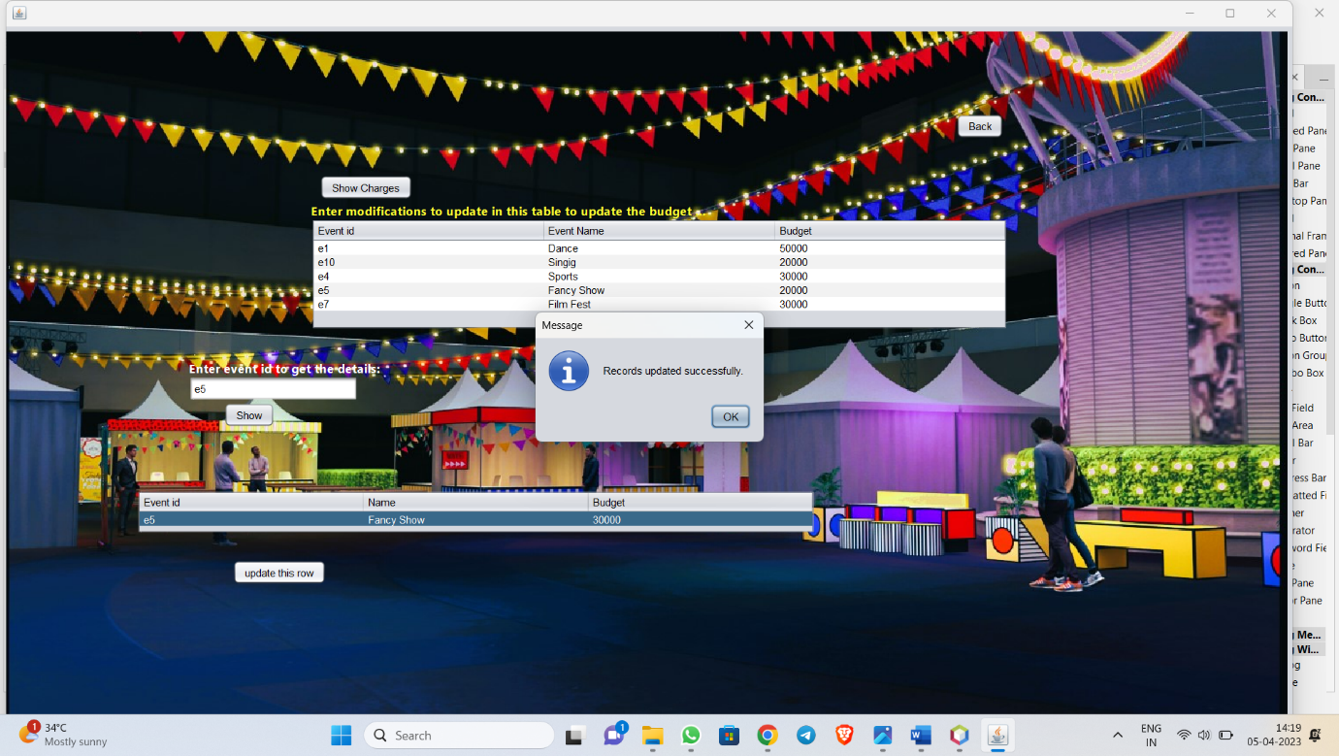

Code

try{

Class.forName("com.mysql.jdbc.Driver");

Connection con =DriverManager.getConnection("jdbc:mysql://localhost:3306/demo","root","root");

Statement st=con.createStatement();

String sql="select * from faculty_info";

ResultSet rs=st.executeQuery(sql);

DefaultTableModel model=(DefaultTableModel)jTable1.getModel();

model.setRowCount(0);

while(rs.next())

{

model.addRow(new String[]{rs.getString(1),rs.getString(2),rs.getString(3),rs.getString(4)});

}

}

catch(Exception e)

{

JOptionPane.showMessageDialog(this,e);

}

}

private void jButton2ActionPerformed(java.awt.event.ActionEvent evt) {

// TODO add your handling code here:

try{

Class.forName("com.mysql.jdbc.Driver");

Connection con =DriverManager.getConnection("jdbc:mysql://localhost:3306/demo","root","root");

String query="insert into faculty_info values(?,?,?,?)";

DefaultTableModel model = (DefaultTableModel) jTable3.getModel();

java.sql.PreparedStatement ps=con.prepareStatement(query);

for (int i = 0; i < model.getRowCount(); i++) {

String forgid = model.getValueAt(i, 0).toString();

String fid = model.getValueAt(i, 1).toString();

String ename = model.getValueAt(i, 2).toString();

String mno= model.getValueAt(i, 3).toString();

if (forgid != null && fid != null && ename != null && mno != null) {

ps.setString(1, forgid);

ps.setString(2, fid);

ps.setString(3, ename);

ps.setString(4, mno);

ps.addBatch();

ps.clearParameters();

if (i % 100 == 0) {

ps.executeBatch(); // Execute batch every 100 rows

}

}

}

ps.executeBatch(); // Execute remaining batch

JOptionPane.showMessageDialog(this, "successfully inserted");

DefaultTableModel model1=(DefaultTableModel)jTable1.getModel();

int r = jTable1.getRowCount();

model1.addRow(new String[]{model.getValueAt(0, 0).toString(),model.getValueAt(0, 1).toString(),model.getValueAt(0, 2).toString(),model.getValueAt(0, 3).toString()});

model.setRowCount(0);

model.addRow(new String[]{"","","",""});

ps.close();

con.close();

} catch (SQLException ex) {

Logger.getLogger(Faculty_management.class.getName()).log(Level.SEVERE, null, ex);

} catch (ClassNotFoundException ex) {

Logger.getLogger(Faculty_management.class.getName()).log(Level.SEVERE, null, ex);

}

}

private void jButton3ActionPerformed(java.awt.event.ActionEvent evt) {

// TODO add your handling code here:

try {

// Load the MySQL driver

Class.forName("com.mysql.jdbc.Driver");

// Create a connection to the MySQL database

Connection connection = DriverManager.getConnection("jdbc:mysql://localhost:3306/demo", "root", "root");

// Create a statement to execute the SQL query

Statement statement = connection.createStatement();

// Execute the SQL DELETE statement to remove all data from the table

String sql = "DELETE FROM faculty_info;";

int rowsAffected = statement.executeUpdate(sql);

JOptionPane.showMessageDialog(this,rowsAffected+"faculty deleted");

// Output the number of rows affected

// Close the statement and connection

statement.close();

connection.close();

} catch (ClassNotFoundException e) {

System.err.println("Unable to load database driver: " + e.getMessage());

} catch (SQLException e) {

System.err.println("Unable to connect to database: " + e.getMessage());

}

}

private void jButton4ActionPerformed(java.awt.event.ActionEvent evt) {

// TODO add your handling code here:

try {

// Load the MySQL driver

Class.forName("com.mysql.jdbc.Driver");

// Create a connection to the MySQL database

Connection connection = DriverManager.getConnection("jdbc:mysql://localhost:3306/demo", "root", "root");

// Get the ID to be deleted from the text field

String idToDelete = jTextField1.getText();

// Create a prepared statement to execute the SQL DELETE statement

String sql = "DELETE FROM faculty_info WHERE org_faculty_team_number = ?";

PreparedStatement statement = connection.prepareStatement(sql);

statement.setString(1, idToDelete);

// Execute the SQL statement to delete the employee

int rowsAffected = statement.executeUpdate();

JOptionPane.showMessageDialog(this,rowsAffected+"faculty deleted");

jTextField1.setText("");

Statement st=connection.createStatement();

String sq="select * from faculty_info";

ResultSet rs=st.executeQuery(sq);

DefaultTableModel model=(DefaultTableModel)jTable1.getModel();

model.setRowCount(0);

while(rs.next())

{

model.addRow(new String[]{rs.getString(1),rs.getString(2),rs.getString(3),rs.getString(4)});

}

statement.close();

connection.close();

} catch (ClassNotFoundException e) {

System.err.println("Unable to load database driver: " + e.getMessage());

} catch (SQLException e) {

System.err.println("Unable to connect to database: " + e.getMessage());

}

}

private void jButton5ActionPerformed(java.awt.event.ActionEvent evt) {

// TODO add your handling code here:

try {

// Load the MySQL driver

Class.forName("com.mysql.jdbc.Driver");

// Create a connection to the MySQL database

Connection connection = DriverManager.getConnection("jdbc:mysql://localhost:3306/demo", "root", "root");

// Get the ID to be deleted from the text field

String idToDelete = jTextField2.getText();

// Create a prepared statement to execute the SQL DELETE statement

String sql = "DELETE FROM faculty_info WHERE f_id= ?";

PreparedStatement statement = connection.prepareStatement(sql);

statement.setString(1, idToDelete);

// Execute the SQL statement to delete the employee

int rowsAffected = statement.executeUpdate();

JOptionPane.showMessageDialog(this,rowsAffected+"faculty deleted");

jTextField2.setText("");

Statement st=connection.createStatement();

String sq="select * from faculty_info";

ResultSet rs=st.executeQuery(sq);

DefaultTableModel model=(DefaultTableModel)jTable1.getModel();

model.setRowCount(0);

while(rs.next())

{

model.addRow(new String[]{rs.getString(1),rs.getString(2),rs.getString(3),rs.getString(4)});

}

statement.close();

connection.close();

} catch (ClassNotFoundException e) {

System.err.println("Unable to load database driver: " + e.getMessage());

} catch (SQLException e) {

System.err.println("Unable to connect to database: " + e.getMessage());

}

}

private void jButton6ActionPerformed(java.awt.event.ActionEvent evt) {

// TODO add your handling code here:

Adminpage a=new Adminpage();

a.show();

dispose();

}

SCHEDULE MANAGEMENT PAGE

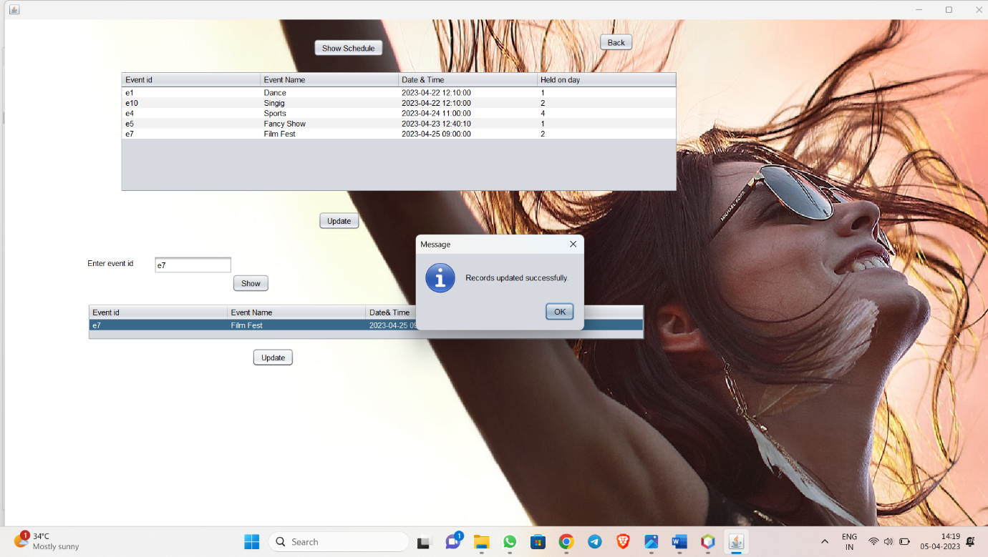

private void jButton1ActionPerformed(java.awt.event.ActionEvent evt) {

// TODO add your handling code here:

try{

Class.forName("com.mysql.jdbc.Driver");

Connection con =DriverManager.getConnection("jdbc:mysql://localhost:3306/demo","root","root");

Statement st=con.createStatement();

String sql="select e_id,ename,edate_time,day from event_details";

ResultSet rs=st.executeQuery(sql);

DefaultTableModel model=(DefaultTableModel)jTable1.getModel();

model.setRowCount(0);

while(rs.next())

{

String dateTimeString = rs.getTimestamp(3).toString();

SimpleDateFormat sdf = new SimpleDateFormat("yyyy-MM-dd HH:mm:ss");

java.util.Date dateTime = sdf.parse(dateTimeString);

String formattedDateTimeString = sdf.format(dateTime);

model.addRow(new String[]{rs.getString(1),rs.getString(2),formattedDateTimeString ,String.valueOf(rs.getInt(4))});

}

}

catch(Exception e)

{

JOptionPane.showMessageDialog(this,e);

}

}

private void jButton2ActionPerformed(java.awt.event.ActionEvent evt) {

// TODO add your handling code here:

try {

Class.forName("com.mysql.jdbc.Driver");

Connection con = DriverManager.getConnection("jdbc:mysql://localhost:3306/demo", "root", "root");

DefaultTableModel model = (DefaultTableModel) jTable1.getModel();

String updateQuery = "UPDATE event_details SET edate_time=?,day=? WHERE e_id=?";

java.sql.PreparedStatement st = con.prepareStatement(updateQuery);

for (int i = 0; i < model.getRowCount(); i++) {

String id = model.getValueAt(i, 0).toString();

int day=Integer.parseInt(model.getValueAt(i, 3).toString());

String dateTimeString = model.getValueAt(i, 2).toString();

SimpleDateFormat sdf = new SimpleDateFormat("yyyy-MM-dd HH:mm:ss");

java.util.Date dateTime = sdf.parse(dateTimeString);

Timestamp timestamp = new Timestamp(dateTime.getTime());

st.setTimestamp(1, timestamp);

st.setInt(2, day);

st.setString(3, id);

st.addBatch();

}

st.executeBatch();

JOptionPane.showMessageDialog(this, "Records updated successfully.");

Statement st1=con.createStatement();

String sql="select * from event_details";

ResultSet rs=st1.executeQuery(sql);

DefaultTableModel model1=(DefaultTableModel)jTable1.getModel();

model1.setRowCount(0);

while(rs.next())

{

String dateTimeString = rs.getTimestamp(4).toString();

SimpleDateFormat sdf = new SimpleDateFormat("yyyy-MM-dd HH:mm:ss");

java.util.Date dateTime = sdf.parse(dateTimeString);

String formattedDateTimeString = sdf.format(dateTime);

model1.addRow(new String[]{rs.getString(1),rs.getString(3),formattedDateTimeString,String.valueOf(rs.getInt(2))});

}

}

catch (Exception e) {

JOptionPane.showMessageDialog(this, e.getMessage());

}

}

private void jButton4ActionPerformed(java.awt.event.ActionEvent evt) {

// TODO add your handling code here:

try {

Class.forName("com.mysql.jdbc.Driver");

Connection con = DriverManager.getConnection("jdbc:mysql://localhost:3306/demo", "root", "root");

String sq = "SELECT * FROM event_details WHERE e_id=?";

java.sql.PreparedStatement ps = con.prepareStatement(sq);

ps.setString(1, jTextField1.getText());

ResultSet rs = ps.executeQuery();

if (!rs.next()) {

JOptionPane.showMessageDialog(this, "Record not found.");

} else {

String query1 = "SELECT e_id, ename,edate_time,day from event_details WHERE e_id=?";

java.sql.PreparedStatement ps1 = con.prepareStatement(query1);

ps1.setString(1, jTextField1.getText());

rs = ps1.executeQuery();

DefaultTableModel model = (DefaultTableModel) jTable3.getModel();

model.setRowCount(0);

while (rs.next()) {

String dateTimeString = rs.getTimestamp(3).toString();

SimpleDateFormat sdf = new SimpleDateFormat("yyyy-MM-dd HH:mm:ss");

java.util.Date dateTime = sdf.parse(dateTimeString);

String formattedDateTimeString = sdf.format(dateTime);

model.addRow(new String[]{rs.getString(1), rs.getString(2),formattedDateTimeString, String.valueOf(rs.getInt(4))});

}

}

con.close();

} catch (Exception e) {

JOptionPane.showMessageDialog(this, e.getMessage());

}

}

private void jButton3ActionPerformed(java.awt.event.ActionEvent evt) {

// TODO add your handling code here:

try {

Class.forName("com.mysql.jdbc.Driver");

Connection con = DriverManager.getConnection("jdbc:mysql://localhost:3306/demo", "root", "root");

DefaultTableModel model = (DefaultTableModel) jTable3.getModel();

String updateQuery = "UPDATE event_details SET edate_time=?,day=? WHERE e_id=?";

java.sql.PreparedStatement st = con.prepareStatement(updateQuery);

for (int i = 0; i < model.getRowCount(); i++) {

String id = model.getValueAt(i, 0).toString();

int d=Integer.parseInt(model.getValueAt(i, 3).toString());

String dateTimeString = model.getValueAt(i, 2).toString();

SimpleDateFormat sdf = new SimpleDateFormat("yyyy-MM-dd HH:mm:ss");

java.util.Date dateTime = sdf.parse(dateTimeString);

Timestamp timestamp = new Timestamp(dateTime.getTime());

st.setTimestamp(1, timestamp);

st.setInt(2, d);

st.setString(3, id);

st.addBatch();

}

st.executeBatch();

JOptionPane.showMessageDialog(this, "Records updated successfully.");

Statement st1=con.createStatement();

String sql="select * from event_details";

ResultSet rs=st1.executeQuery(sql);

DefaultTableModel model1=(DefaultTableModel)jTable1.getModel();

model1.setRowCount(0);

while(rs.next())

{

String dateTimeString = rs.getTimestamp(4).toString();

SimpleDateFormat sdf = new SimpleDateFormat("yyyy-MM-dd HH:mm:ss");

java.util.Date dateTime = sdf.parse(dateTimeString);

String formattedDateTimeString = sdf.format(dateTime);

model1.addRow(new String[]{rs.getString(1),rs.getString(3),formattedDateTimeString,String.valueOf(rs.getInt(2) )});

}

} catch (Exception e) {

JOptionPane.showMessageDialog(this, e.getMessage());

}

}

private void jButton5ActionPerformed(java.awt.event.ActionEvent evt) {

// TODO add your handling code here:

Adminpage a=new Adminpage();

a.show();

dispose();

}

/**

* @param args the command line arguments

*/

public static void main(String args[]) {

/* Set the Nimbus look and feel */

//<editor-fold defaultstate="collapsed" desc=" Look and feel setting code (optional) ">

/* If Nimbus (introduced in Java SE 6) is not available, stay with the default look and feel.

* For details see http://download.oracle.com/javase/tutorial/uiswing/lookandfeel/plaf.html

*/

try {

for (javax.swing.UIManager.LookAndFeelInfo info : javax.swing.UIManager.getInstalledLookAndFeels()) {

if ("Nimbus".equals(info.getName())) {

javax.swing.UIManager.setLookAndFeel(info.getClassName());

break;

}

}

} catch (ClassNotFoundException ex) {

java.util.logging.Logger.getLogger(Schedule_management.class.getName()).log(java.util.logging.Level.SEVERE, null, ex);

} catch (InstantiationException ex) {

java.util.logging.Logger.getLogger(Schedule_management.class.getName()).log(java.util.logging.Level.SEVERE, null, ex);

} catch (IllegalAccessException ex) {

java.util.logging.Logger.getLogger(Schedule_management.class.getName()).log(java.util.logging.Level.SEVERE, null, ex);

} catch (javax.swing.UnsupportedLookAndFeelException ex) {

java.util.logging.Logger.getLogger(Schedule_management.class.getName()).log(java.util.logging.Level.SEVERE, null, ex);

}

//</editor-fold>

/* Create and display the form */

java.awt.EventQueue.invokeLater(new Runnable() {

public void run() {

new Schedule_management().setVisible(true);

}

});

}

FORGOT PASSWORD PAGE

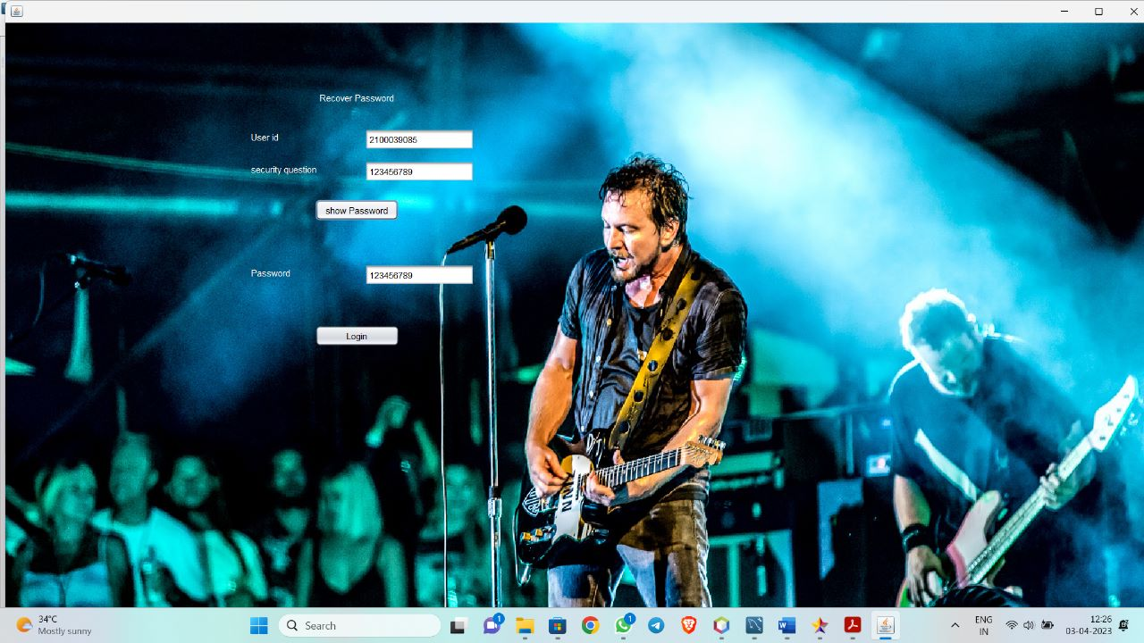

SOURCE CODE FOR PASSWORD RECOVERY

try{

Class.forName("com.mysql.jdbc.Driver");

Connection con =DriverManager.getConnection("jdbc:mysql://localhost:3306/demo","root","root");

String query="select * from user_details where id=?";

java.sql.PreparedStatement ps=con.prepareStatement(query);

ps.setString(1,tx1.getText());

ResultSet rs=ps.executeQuery();

if(rs.next())

{

String query1="select * from user_details where id= ? and security_que=?";

java.sql.PreparedStatement ps1=con.prepareStatement(query1);

ps1.setString(1,tx1.getText());

ps1.setString(2,tx2.getText());

ResultSet rs1=ps1.executeQuery();

if(rs1.next())

{

tx3.setText(rs1.getString(7));

}

else{

JOptionPane.showMessageDialog(null,"Security question is incorrect");

}

}

else{

JOptionPane.showMessageDialog(null,"user not there");

tx1.setText("");

tx2.setText("");

}

ps.close();

con.close();

}

catch(Exception e){

JOptionPane.showMessageDialog(null,e);

}

USER HOME PAGE

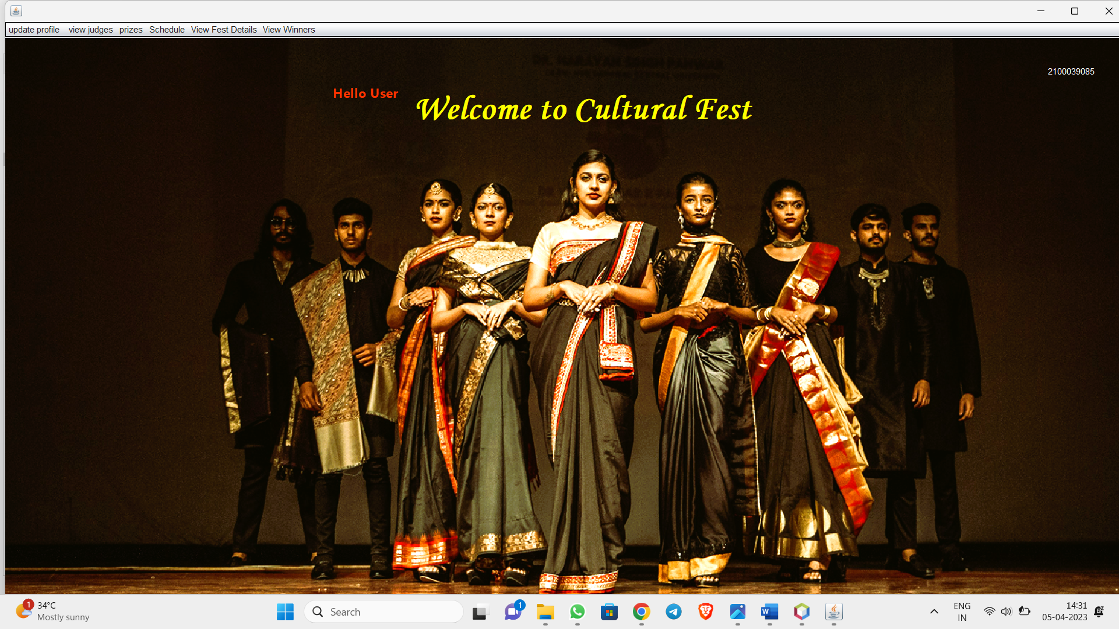

private void jMenu3MouseClicked(java.awt.event.MouseEvent evt) {

// TODO add your handling code here:

viewJudgesUser v=new viewJudgesUser(u_id.getText());

v.show();

dispose();

}

private void jMenu6MouseClicked(java.awt.event.MouseEvent evt) {

// TODO add your handling code here:

ViewTimingsuser v=new ViewTimingsuser(u_id.getText());

v.show();

dispose();

}

private void jMenu4MouseClicked(java.awt.event.MouseEvent evt) {

// TODO add your handling code here:

viewprizesuser v=new viewprizesuser(u_id.getText());

v.show();

dispose();

}

private void jMenu1MouseClicked(java.awt.event.MouseEvent evt) {

// TODO add your handling code here:

updateProfile u=new updateProfile(u_id.getText());

u.show();

dispose();

}

private void jMenu2MouseClicked(java.awt.event.MouseEvent evt) {

// TODO add your handling code here:

viewScheduleUser v=new viewScheduleUser(u_id.getText());

v.show();

dispose();

}

private void jMenu5MouseClicked(java.awt.event.MouseEvent evt) {

// TODO add your handling code here:

view_winners_user v=new view_winners_user();

v.show();

dispose();

}

Snap shots for view judges

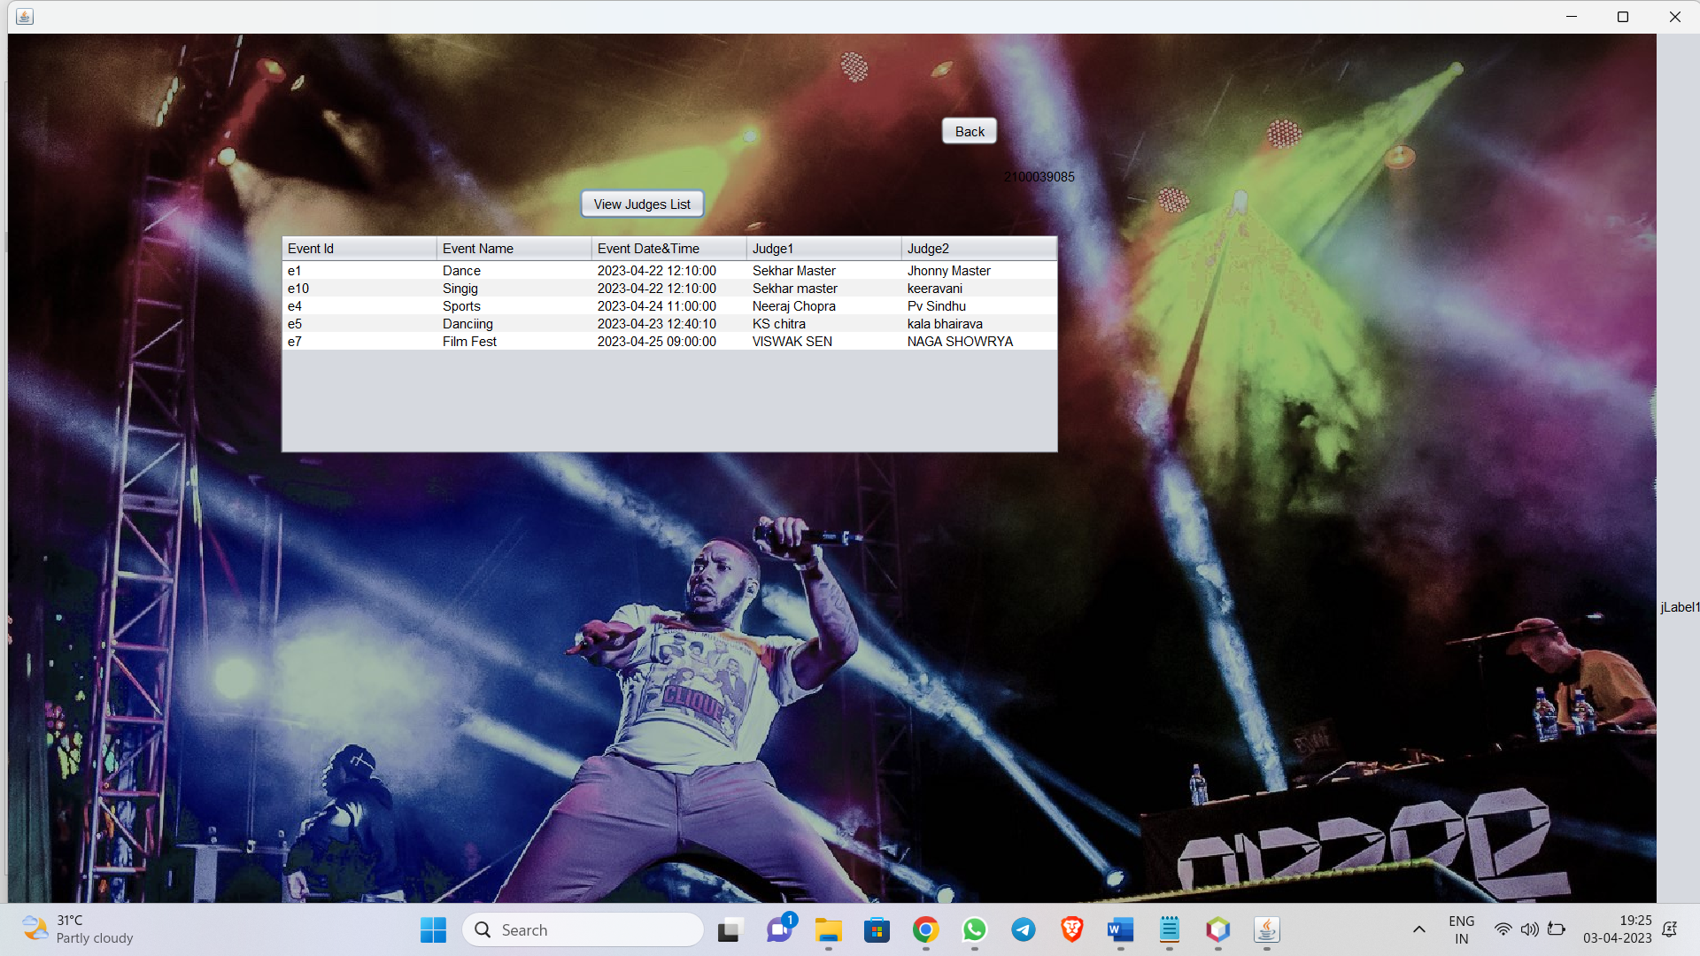

Source code:

private void jButton1ActionPerformed(java.awt.event.ActionEvent evt) {

// TODO add your handling code here:

try{

Class.forName("com.mysql.jdbc.Driver");

Connection con =DriverManager.getConnection("jdbc:mysql://localhost:3306/demo","root","root");

Statement st=con.createStatement();

String sql="select e_id,ename,edate_time,judge1,judge2 from event_details";

ResultSet rs=st.executeQuery(sql);

DefaultTableModel model=(DefaultTableModel)jTable1.getModel();

model.setRowCount(0);

while(rs.next())

{

String dateTimeString = rs.getTimestamp(3).toString();

SimpleDateFormat sdf = new SimpleDateFormat("yyyy-MM-dd HH:mm:ss");

java.util.Date dateTime = sdf.parse(dateTimeString);

String formattedDateTimeString = sdf.format(dateTime);

model.addRow(new String[]{rs.getString(1),rs.getString(2),formattedDateTimeString ,rs.getString(4),rs.getString(5)});

}

}

catch(Exception e)

{

JOptionPane.showMessageDialog(this,e);

}

}

Update profile Page

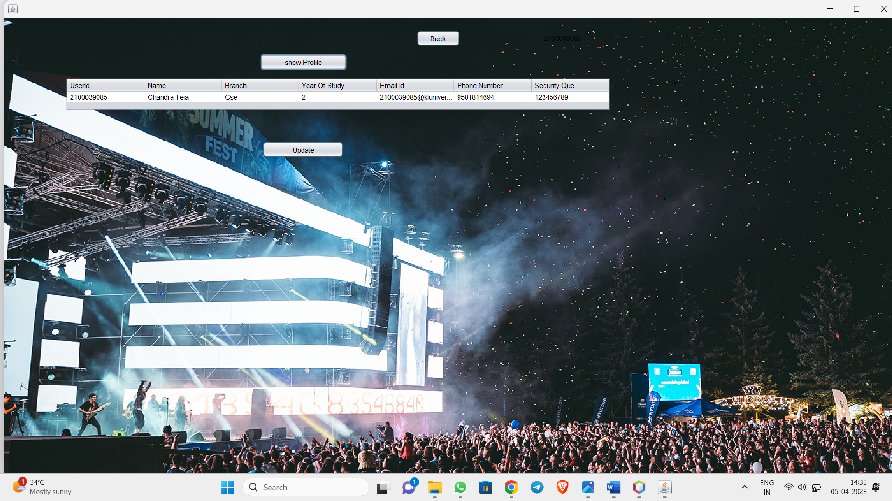

Code:

private void jButton2ActionPerformed(java.awt.event.ActionEvent evt) {

// TODO add your handling code here:

try {

Class.forName("com.mysql.jdbc.Driver");

Connection con = DriverManager.getConnection("jdbc:mysql://localhost:3306/demo", "root", "root");

DefaultTableModel model = (DefaultTableModel) jTable1.getModel();

// Prepare the update statement

String updateQuery = "UPDATE user_details SET name=?, branch=?, yos=?, emailid=?, phonenumber=?, security_que=? WHERE id=?";

PreparedStatement st = con.prepareStatement(updateQuery);

// Add the update statements to the batch

for (int i = 0; i < model.getRowCount(); i++) {

String id = model.getValueAt(i, 0).toString();

String name = model.getValueAt(i, 1).toString();

String branch = model.getValueAt(i, 2).toString();

int yos = Integer.parseInt(model.getValueAt(i, 3).toString());

String email = model.getValueAt(i, 4).toString();

String phoneNumber = model.getValueAt(i, 5).toString();

String securityQuestion = model.getValueAt(i, 6).toString();

st.setString(1, name);

st.setString(2, branch);

st.setInt(3, yos);

st.setString(4, email);

st.setString(5, phoneNumber);

st.setString(6, securityQuestion);

st.setString(7, id);

st.addBatch();

}

// Execute the batch update

st.executeBatch();

JOptionPane.showMessageDialog(this, "Records updated successfully.");

// Retrieve the updated data from the database

String selectQuery = "SELECT * FROM user_details WHERE id=?";

PreparedStatement st2 = con.prepareStatement(selectQuery);

DefaultTableModel model1 = (DefaultTableModel) jTable1.getModel();

String id = model1.getValueAt(0, 0).toString();

st2.setString(1, id);

ResultSet rs = st2.executeQuery();

model1.setRowCount(0);

while (rs.next()) {

String name = rs.getString(2);

String branch = rs.getString(3);

int yos = rs.getInt(4);

String email = rs.getString(5);

String phoneNumber = rs.getString(6);

String securityQuestion = rs.getString(7);

model1.addRow(new String[]{id, name, branch, String.valueOf(yos), email, phoneNumber, securityQuestion});

}

// Close the database resources

rs.close();

st2.close();

st.close();

con.close();

} catch (Exception e) {

JOptionPane.showMessageDialog(this, e.getMessage());

}

}

private void jButton1ActionPerformed(java.awt.event.ActionEvent evt) {

// TODO add your handling code here:

try{

Class.forName("com.mysql.jdbc.Driver");

Connection con =DriverManager.getConnection("jdbc:mysql://localhost:3306/demo","root","root");

String query="select * from user_details where id=?";

java.sql.PreparedStatement ps=con.prepareStatement(query);

String Id=id.getText();

ps.setString(1,Id);

ResultSet rs=ps.executeQuery();

DefaultTableModel model = (DefaultTableModel) jTable1.getModel();

model.setRowCount(0);

while (rs.next()) {

model.addRow(new String[]{rs.getString(1), rs.getString(2), rs.getString(3), String.valueOf(rs.getInt(4)),rs.getString(5), rs.getString(6), rs.getString(8)});

}

rs.close();

ps.close();

con.close();

}catch(Exception e)

{

System.out.println(e);

}

}

private void jButton3ActionPerformed(java.awt.event.ActionEvent evt) {

// TODO add your handling code here:

userhome u=new userhome(id.getText());

u.show();

dispose();

}

CONCLUSION

The Cultural Fest Management System is designed to provide a comprehensive and user-friendly interface to manage cultural festivals. The system provides features to manage users, participants,

cash prizes, guests, stalls, ongoing events. The system is designed to be secure, reliable, easy to use.

The use case diagram represents the various actions that can be performed by the actors (users) in the system. The actors in this system are Event Organizer and Participant.

REFERENCE

1. Introduction to Java Programming, Comprehensive Version, 10th Edition by Y. Daniel Liang.
2. Herbert Scheldt, “The Complete Reference Java”, 7th edition TMH.

3. Timothy A. Budd, “an Introduction to Object-Oriented

Programming”, 3/e, Pearson, 2008.

4. UML Distilled by Martin Fowler.